Text-message Marketing

(images from istockphoto) File #: 2439379

According to CTIA, the Wireless Association, three and a half billion text messages are sent daily. Out of those three and a half billion text messages, 97% of them are opened and read. People rely on their phones to receive information more than a person does opening email after email. Businesses are starting to incorporate text-message marketing in their advertising to attract their target audiences.
What is Text-message Marketing?
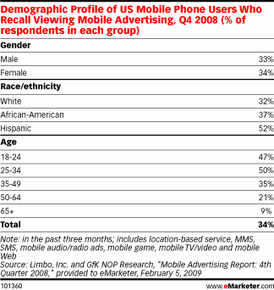
Text-message marketing is a way for businesses to reach their target audience with information, promotions, coupons etc… in the form of a text-message.
According to emarketer.com, text-message marketing is most effective with those who text more.
In Promo Magazine, marketers found that in 2007, 13.3 percent of mobile phone users were investing in text-message promotions and coupons. In 2009, 26 percent of mobile phone users were investing.
In this table, 47 percent of people between the ages of 18-24 and 50 percent of people between the ages of 25-34 have viewed mobile advertising. Text-message marketing can give businesses another effective way to reach young adults and teenagers.
If your audience is comprised of these young adults and teenagers, this is a good way to advertise.
How to Get Started
Now that you know what text-message marketing is and the type of audience it normally reaches, how do you get your business started in this type of advertising?
- The first thing your business needs to do is pick a service provider or find SMS software. There are multiple companies out on the web. If you do a search on Google, you will find plenty of choices to choose from.
- Next, you need to advertise that you are using text-message marketing. A good place to advertise is in your place of business, company website and in a few local newspapers.
- To be successful, ultimately, your business must give your target audience what they want. When your audience signs up to receive texts, thank them for signing up by giving them a good deal on a product. For example, when signing up to receive texts from Bajio Mexican Grill in Rexburg, customers were able to receive a free drink with their meal by showing the cashier the incoming text. Another example comes from a gas station and food mart in Rexburg called Horkley’s. They often give their customers deals on gas or an extra-large drink weekly. Giving promotions can help show that your business cares about its customers and community.
Pros and Cons
There are many ways to decide if text-message marketing would benefit your business. David C Skul, CEO of Relativity Business Technology Solutions, provides pros and cons to this form of advertising:
Pros of Mobile Marketing
- The number of mobile users is almost double that of computer users. This means that there will be a higher penetration of devices and easier access to international consumers who can afford to buy mobile phones but not a PC.
- Cell phones are personal, portable devices that people carry with them most of the time, more so than with a laptop. Likewise, mobile phones are capable of receiving information anytime, anywhere. This makes it easier for marketers to use this medium to establish and strengthen a relationship with the customer.
- Mobile ads are typically personal, interactive, and primed to elicit a response even from on-the-go customers.
- Text messages sent to a mobile phone have a higher likelihood of being read as compared to messages sent via any other medium, including email.
- The opt-in nature of mobile marketing campaigns make them more effective and more target-specific as compared to any other form of advertising.
- Mobile marketing is a great way to build an impressive database. This information can be used later for customer retention and loyalty marketing campaigns.
- The ability of mobile marketing to capitalize on opportune moment increases its effectiveness tremendously. With mobile marketing, the odds are very high that your offer may reach customers while they are actively shopping thus working to effectively leverage their buying decisions.
Cons of Mobile Marketing
- Wireless web technology or WAP (wireless application protocol) is still inadequate and does not encourage web surfing and searching.
- Customers have to be willing to embrace receiving advertising messages on their personal device.
- Messages and content lose their impact and result in poor user experience when they are adapted for the mobile web.
- There are several different carriers as well as an endless variety of handsets with varying functionalities and preloaded applications. All these differences make mobile marketing increasingly complex and fragmented.
- Currently, there are no reliable metrics available for advertisers to measure the effectiveness of their mobile ads.
Some Tips…
- Do keep messages personal and include offers
- Do not use texting “slang” in your texts. Keep your offers and information professional. For example: “We have a deal 4 u!”
- Do be aware of the number of text messages that you send out every week. If your audience is getting text after text, they may feel annoyed and unsubscribe.
- However, do send at least one text message per month so your present customers remember you and keep coming back.
Other Companies Using Text-message Marketing in the Eastern Idaho Area
- Bajio Mexican Grill
- Craigo’s Gourmet Pizza Co.
- Horkley’s
- Schlotzsky’s Deli

Citations
http://www.nytimes.com/2009/09/24/business/smallbusiness/24texting.html?pagewanted=1&_r=1

http://www.boomtext.com/

http://www.relativitycorp.com/mobilemarketing/article8.html

http://www.knowthis.com/blog/postings/basics-of-text-message-marketing-and-the-good-the-bad-and-the-ugly-of-franchising/

File #: 1772335
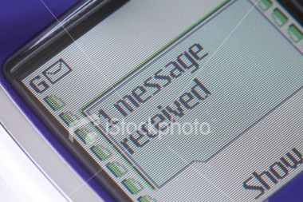

File #: 7298729

